Plant and Soil Science
Disclosure Statement

Instructor: Ms. Tiffany Bushman E-mail address: tiffanybushman@alpinedistrict.org

Course Outline & Introduction
Welcome to Plant and Soil Science! This class will cover the following topics:
-FFA & SAE program -Plant Anatomy & Physiology -Landscaping
-Plant Science Careers -Plant Propagation -Indoor Plant Care
-Soil Properties & Fertility -Garden planning & Management -Flower Garden Planning & Maintenance
-Plant Classification & ID -Turf Management

Absences/Tardies

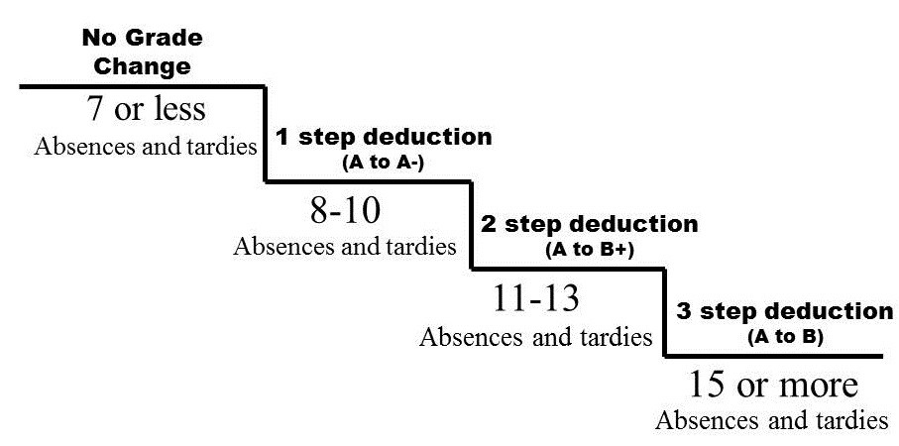
Attending class daily AND arriving to class on time is a must! This is an extremely hands-on class, especially in the spring when most class periods will be spent in the greenhouse. Excessive absences and tardies will result in an overall grade reduction on your final grade according to the scale. School excused absences do not count against your grade, but all other absences do. (including verified absences) If extenuating circumstances occur requiring you to miss an excessive amount of school days, talk to the instructor. An exception can be made IF all missed work is completed so that your grade isn’t affected severely. All grade reductions will be made at the END of the quarter.
*Number of absences & tardies will be added together to calculate grade deduction
*Tardies or absences CANNOT be made up

Late Work
Assignments must be turned in on time. If you are absent, it is up to YOU to get your missed work the day you return!! Students with excused absences will have 1 week to complete and turn in make-up work for full credit. Unexcused and/or truant absences will not be able to make-up work. No late work is accepted without a late pass.

Behavior Policies
Coming to class prepared, having a good attitude, and respecting all members of the class is expected. Students are expected to respect the rights of others and their property including the classroom, lab materials, computers, books, etc. Electronic devices (cell phones, iPods, etc.) are only allowed in the classroom when approved by Ms. Bushman. If they become a problem in my classroom, they will be confiscated. I will not tolerate cheating, offensive language, disruptive behavior, dress code violations, or harassment in my classroom.

Materials Needed for Class
Each student is required to have a 3-ring binder (1-1 ½”) for organizing and keeping notes, assignments and handouts. It is recommended that you have a separate binder for this class only, but you can also have a section in your binder if you prefer. Students are expected to be prepared with their binder, paper, and pen/pencil EVERY DAY. Binders will be graded each quarter for neatness and completeness. It’s very important to keep track of your binder and all of your papers throughout the year. There will be a cupboard in the classroom where binders may be stored. However, you do so at your own risk. If your binder comes up missing, you are still responsible for the content.

Tests, Quizzes, and Grades
I will give prior notice before giving a test, but quizzes are unannounced. I will follow the MCHS grading scale for final letter grades. Grades will ALWAYS be finalized the second to last day of each trimester.

FFA Membership
This class is part of a complete Agriculture Program. FFA will be taught and participation encouraged according to the state curriculum. The National FFA Organization is the nation’s largest youth leadership organization. The main focus of the FFA is to develop leadership traits in youth. The FFA is a vital organization at American Fork High School. Students enrolled in agricultural classes are encouraged to become members of FFA. The annual dues are $20.00 and can be paid to the financial secretary. By becoming a member of the FFA students will be able to participate in contests, develop leadership skills, be eligible for many scholarships, and possibly qualify to receive a number of awards. Full FFA membership and participation will also give you several opportunities for extra credit.

The Mission Statement of the Agricultural Education Program at American Fork High School is three fold:
1) CLASS Instruction in the classroom and laboratory is the beginning of an agriculture program. In this class, students will learn principles and skills related to the animal industry. This program will strive to provide an ethical, sound understanding of American Agriculture.

2) FFA In addition to the classroom atmosphere, students will be encouraged to join the FFA and participate in FFA activities and leadership opportunities. The FFA makes a positive difference in the lives of students by developing their potential for premier leadership, personal growth, and career success.

3) SAE Students can choose an area of interest in agriculture and have a project called a “Supervised Agricultural Experience.” It can be as simple as caring for their lawn/garden or as complex as operating their own small business. It is their choice. Many students use the part time job they already have as their project as long as it can be related to agriculture. The SAE program provides students with hands on, real life, learning opportunities that will develop life skills and prepare them for a career.

Thank you, I’m looking forward to a great year! Feel free to contact me with any questions,

Ms Bushman

Plant and Soil Science
Disclosure Statement Parent/Student/Instructor Agreement

I have read, understand and agree to abide by the procedures for this class.
Name___________________________________ Period___________________
Student Signature_______________________________________________________

I have read and understand the information in this course disclosure statement. I have also discussed the policies and procedures with my student.

Parent/Guardian Signature_____________________________________________ Date _______________

Home phone__________________________ Work/day phone_________________________

E-mail____________________________________ Preferred Method of Contact: ____Email ____Phone

Does your student have access to a computer and the internet at home? Yes No

Additional Notes:

Sign and return this portion. Returning this assignment is required and will be worth 20 points.

